***Amigos***

***A healthy FOOD for a wealthy MOOD***

**Amigos team members:**

Ismailova Sevilya U1810253

Jasurbekova KamolakhonU1810257

Berdieva Janonakhon U1810230

Azimkulova Diyora U1810181

Sobirov Islom U1810195

Mirzakhanov Akhrorboy U1810091

***Link to our Github repo***: <https://github.com/iuthub/ip-group-project-amigos>

***Link to our Website:*** <https://uzamigos.uz>

***Purpose:*** Our website is made to make our customers’ life much easier, wealthier, and happier with food. A lot of people might be working late and stuck at the office, not having the opportunity to cook anything for themselves and their family members. Especially nowadays when lots of them are working remotely and spend their whole day looking at screens of their laptops then, whenever they have free time go and cook something, it is not easy. The solution is simple; they can go straight to our website and order any food they would like to eat. So it online restaurant where customers can order a variety of food.

***Description:*** The customer clicks the link and redirects to our website; it is required to register and fill the corresponding fields with proper information. After that, it will be possible to make any orders. In the menu section, all the dishes are listed so the customer can choose and puts it in the basket. After the process is finished, the customer makes the order. Our service center receives it and starts processing. In one snap, food will be delivered to your doors.  
Admin continuously updates the menu and if any changes occur. The service center monitors all orders and process them. Customers can easily contact us via email, and They can add their feedback, add any preferences about the menu or the website itself. All feedbacks will be viewed and processed as soon as possible.

***Contact Us Page***

This page allows clients to send their feedback to our amigosteamuz@gmail.com email. In order to send the feedback, it is compulsory to have an account. Otherwise, he/she will be redirected to the ‘Sign In’ page. As to check the user input, the server-side validation has been implemented through ContactUsController, which matches whether or not the user input is valid.

Then, user has to fill in and leave any feedback about our restaurant. As it is shown below.

This will be sent to our email with subject name “Client Feedback”

User who has sent the feedback will also receive such message automatically:

***Dashboard***

This Page will be visible only for administrators, who can see all the registered users. Moreover, admin has an option of promoting the user to admin, or instead deleting a certain user. As can be seen, other information such as Name, email and phone number can also be easily obtained from this page.



***Landing Page***

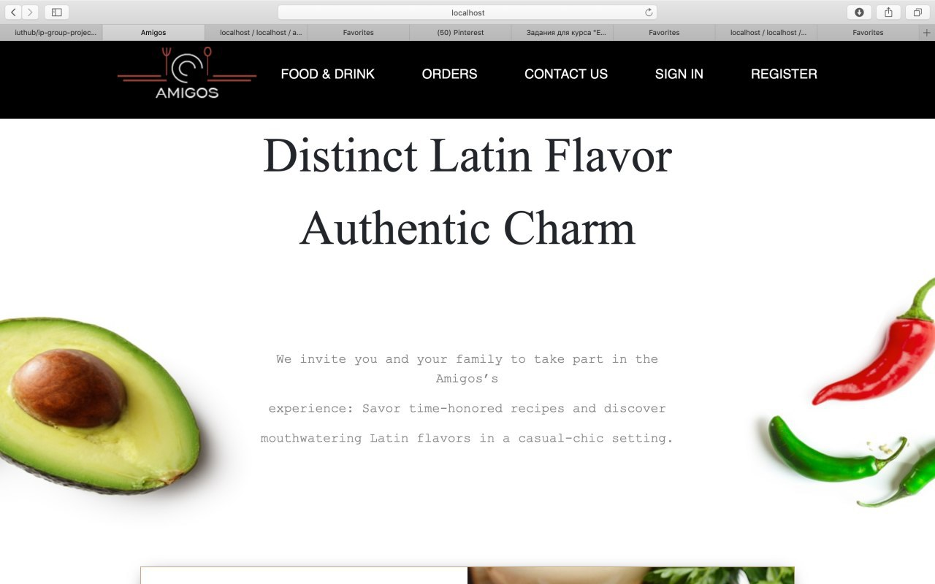

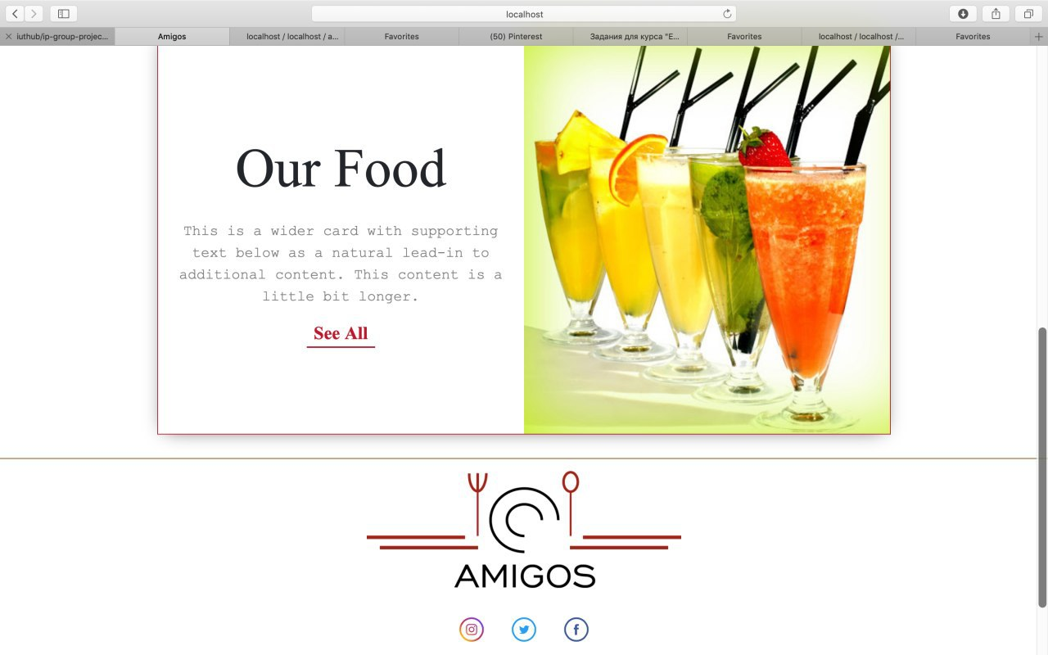

This the Landing Page. The navigation panel is different for users and admins.



This navigation panel is only for unauthorized users. They can’t make any orders.

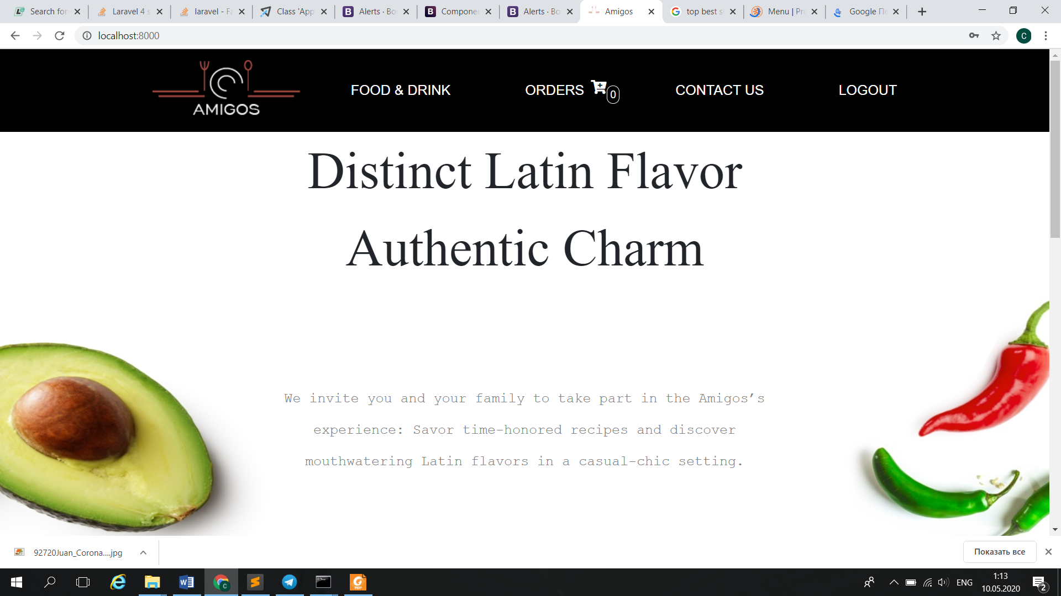

This navigation panel is for authorized users.

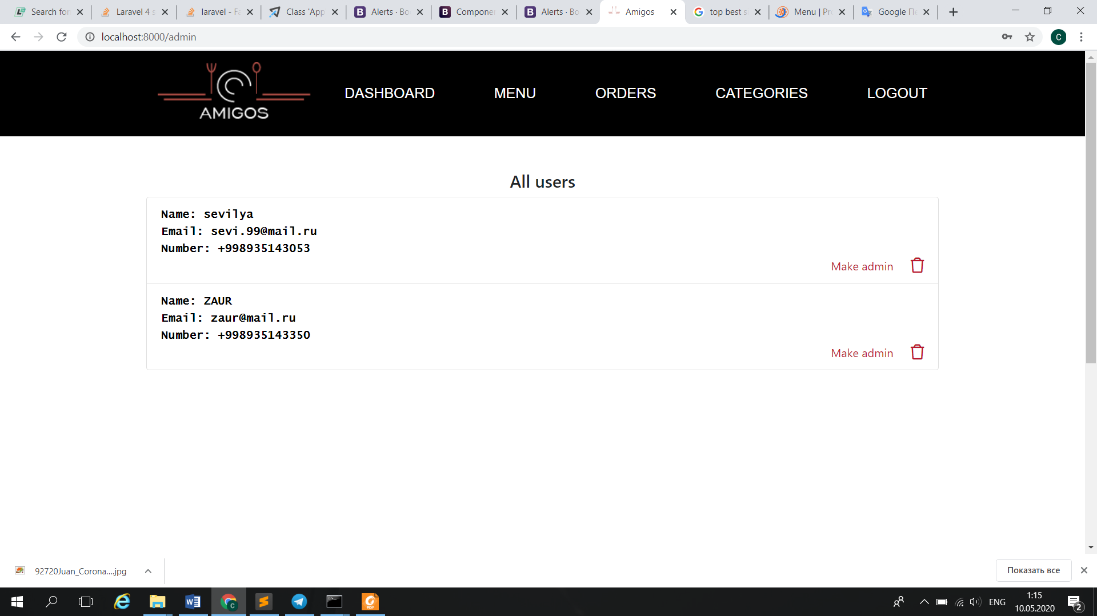

Finally, admin’s navigation panel.

If user press button “See All”, the Food&Drink (Menu) page will be open.

If user press on icons of Facebook, Twitter or Instagram, he will be redirected to official pages of restaurant.

***Registration***

This is registration page. After pressing Register button, all credentials are saved in database (users table). All fields are required to be filled, otherwise the error messages are going to be sent. Password must be minimum 8 char length, number – 9, email should be in the form of email.

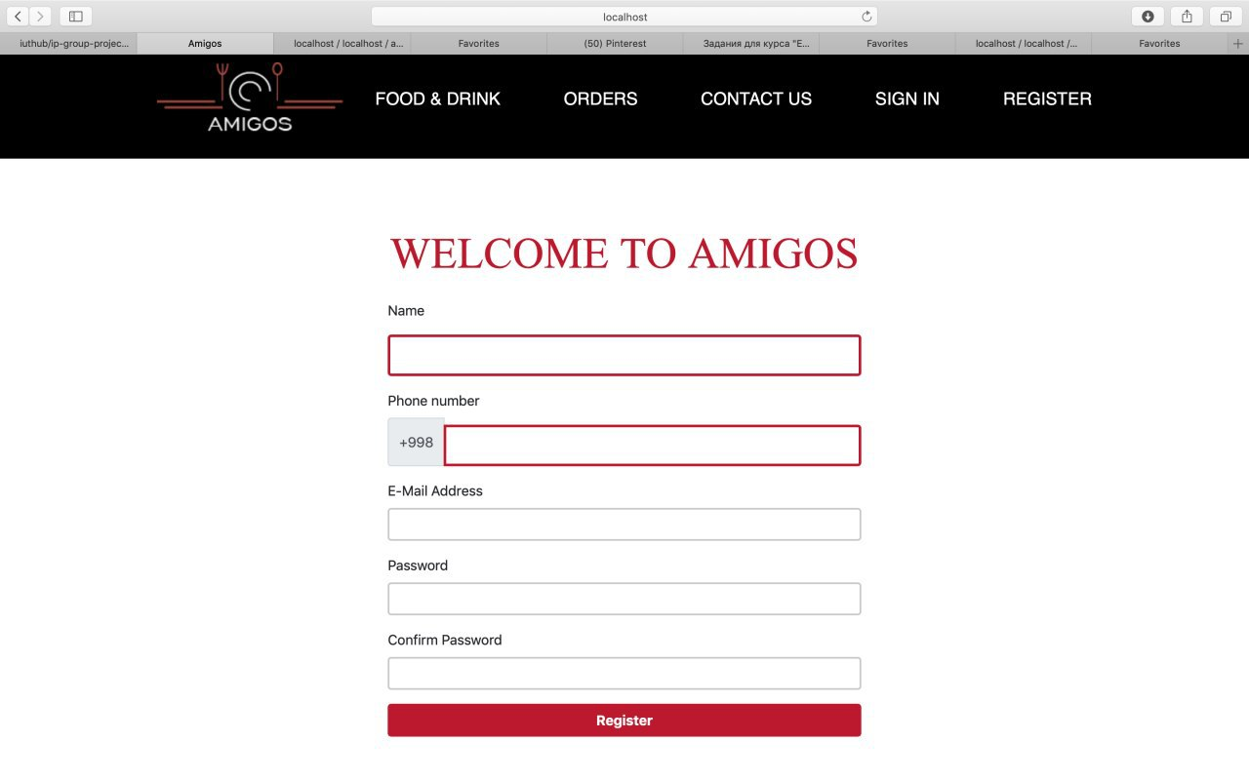

Also, it identifies whether user with same email address is already registered or not.

The confirm password must be exactly the same as password, otherwise the warning message is sent.

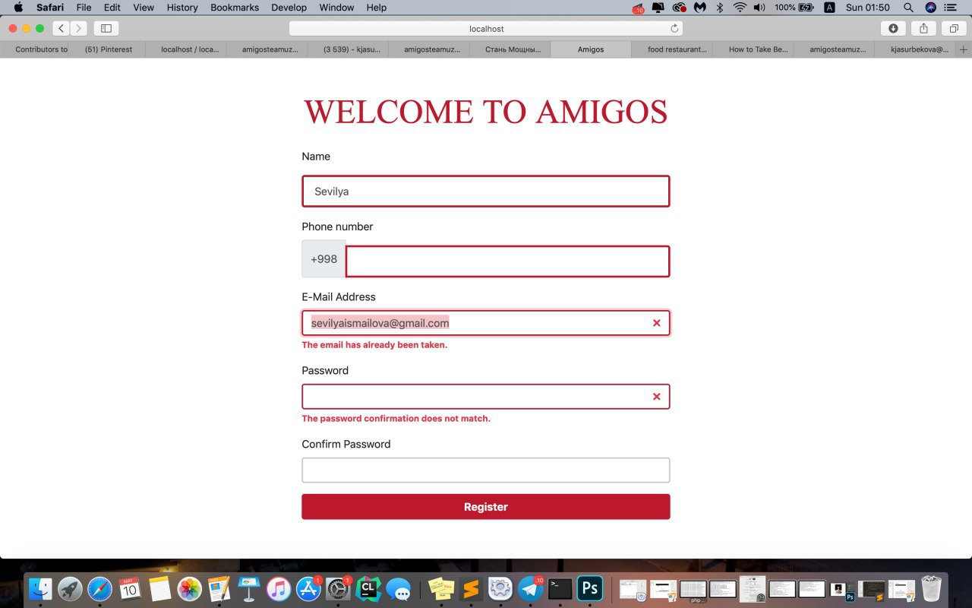

***Sign in***

The sign in page allows authenticated users to enter into their account.

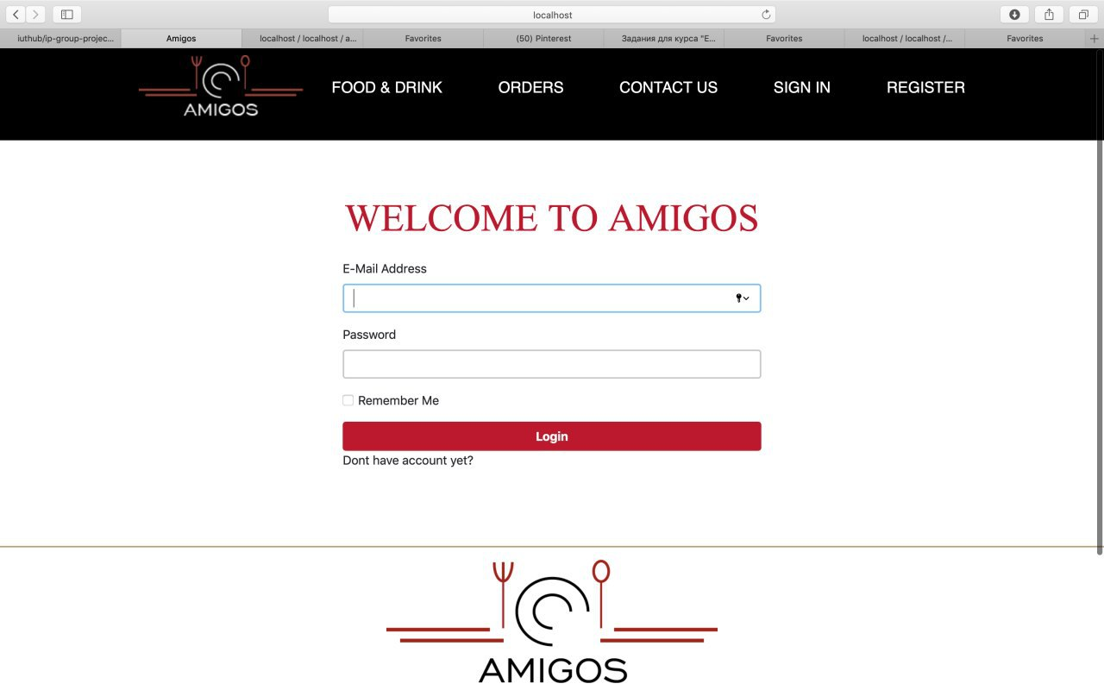

If user is trying to login with email or password that doesn’t much with any in a database, then warning message is sent

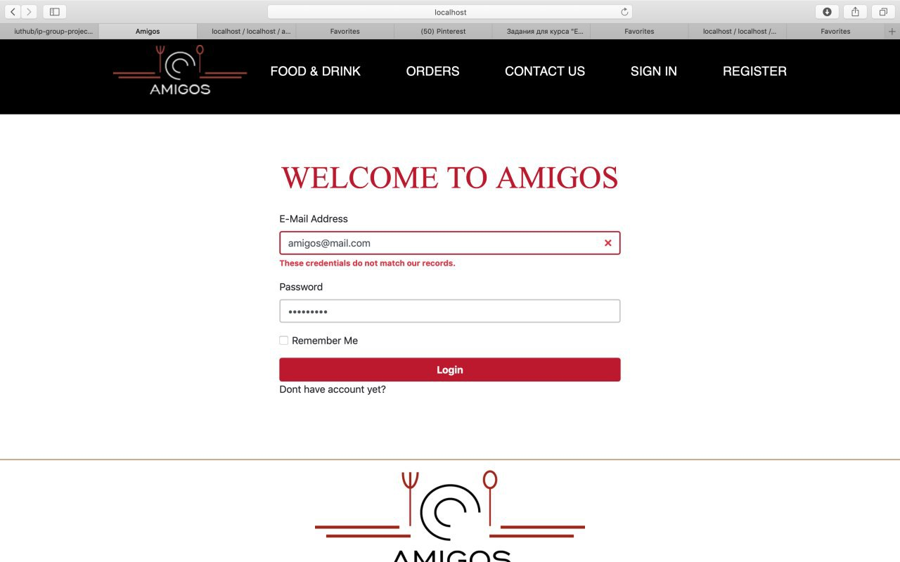

***Category***

Category allCategories page.

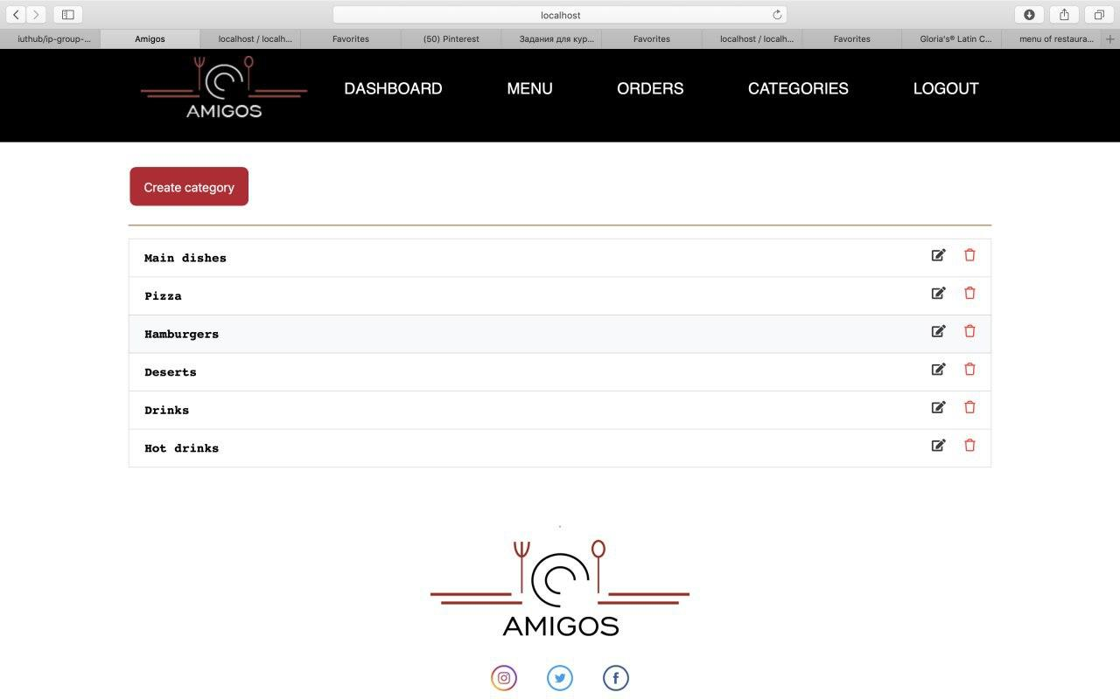

CategoryController index function returns with all categories from database with pagination. This page is accessible to admins only. There, admin can edit or delete category.

***Search***

Customers also can search food in menu. If there is a match, then in a new page all matched foods will be shown. For example, customer input ‘c’

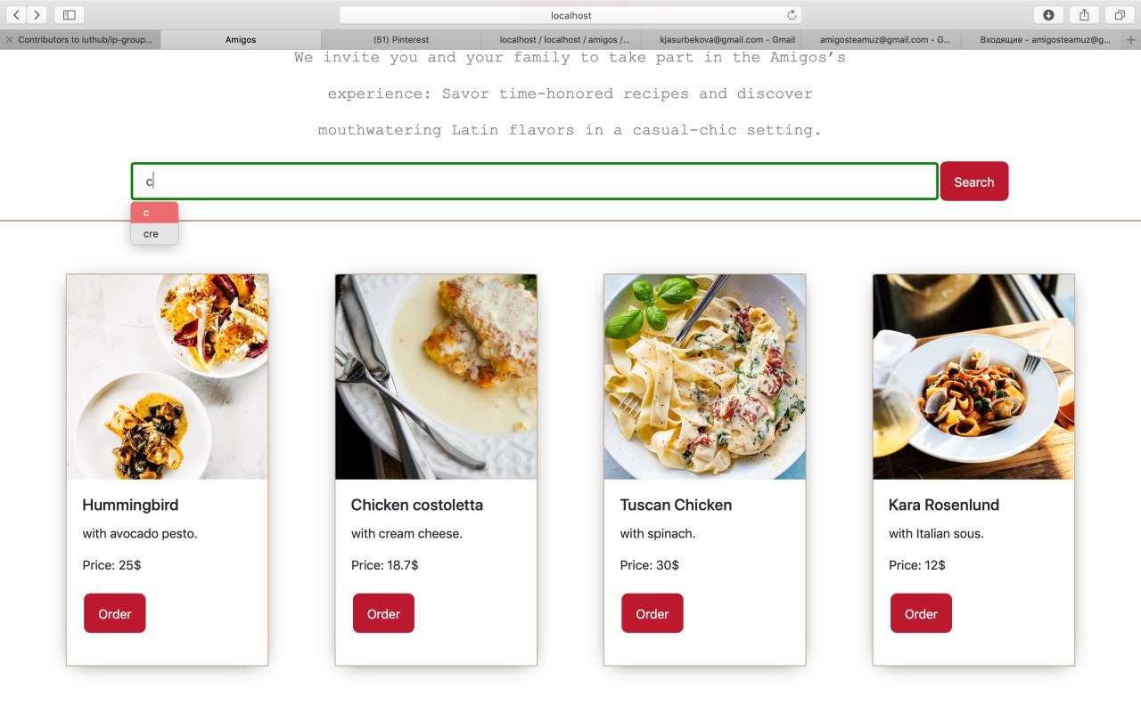

And here all foods that have letter ‘c’

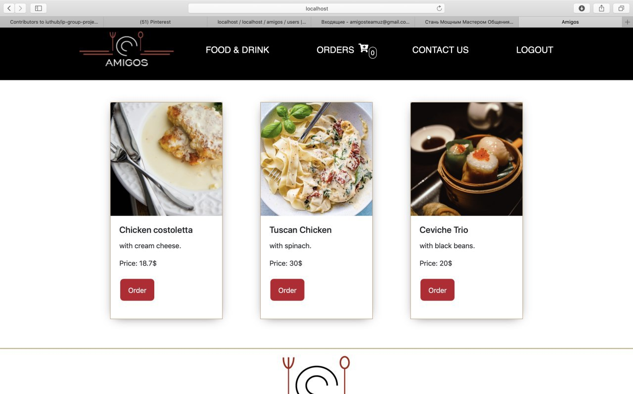

If there is no match, then:

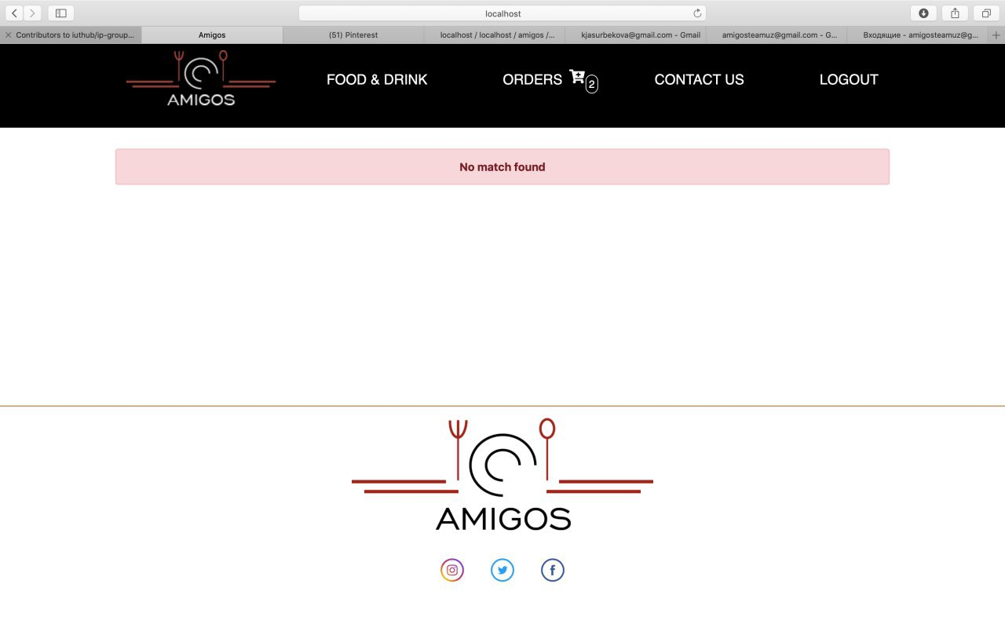

***Menu***

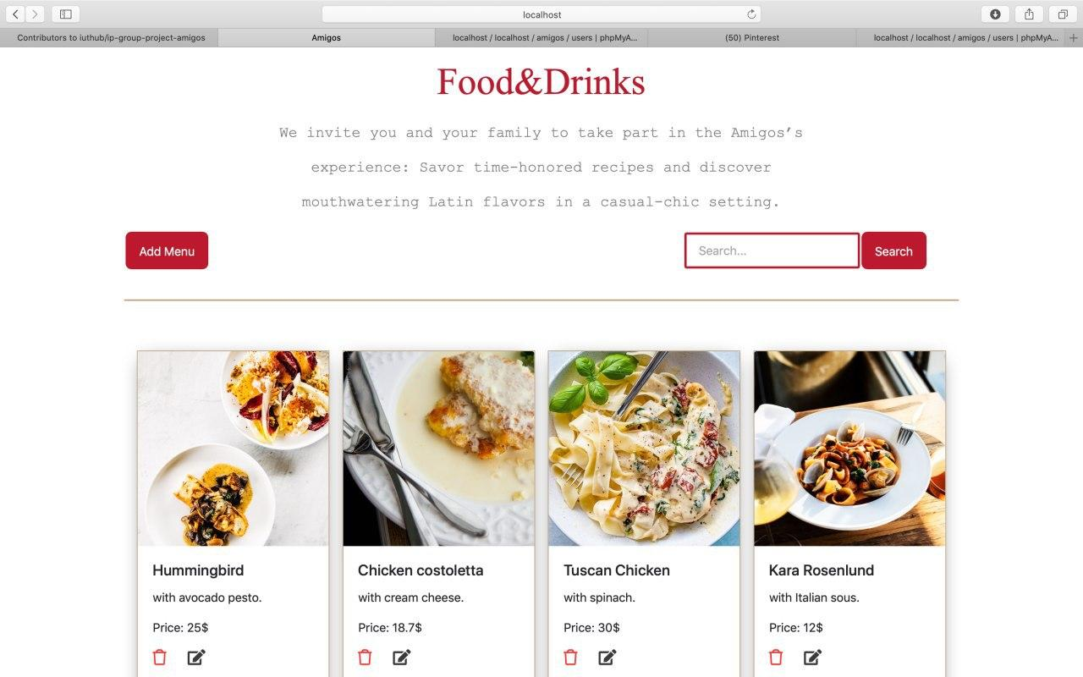

Admin menu page, where admin can create, edit or delete menues.

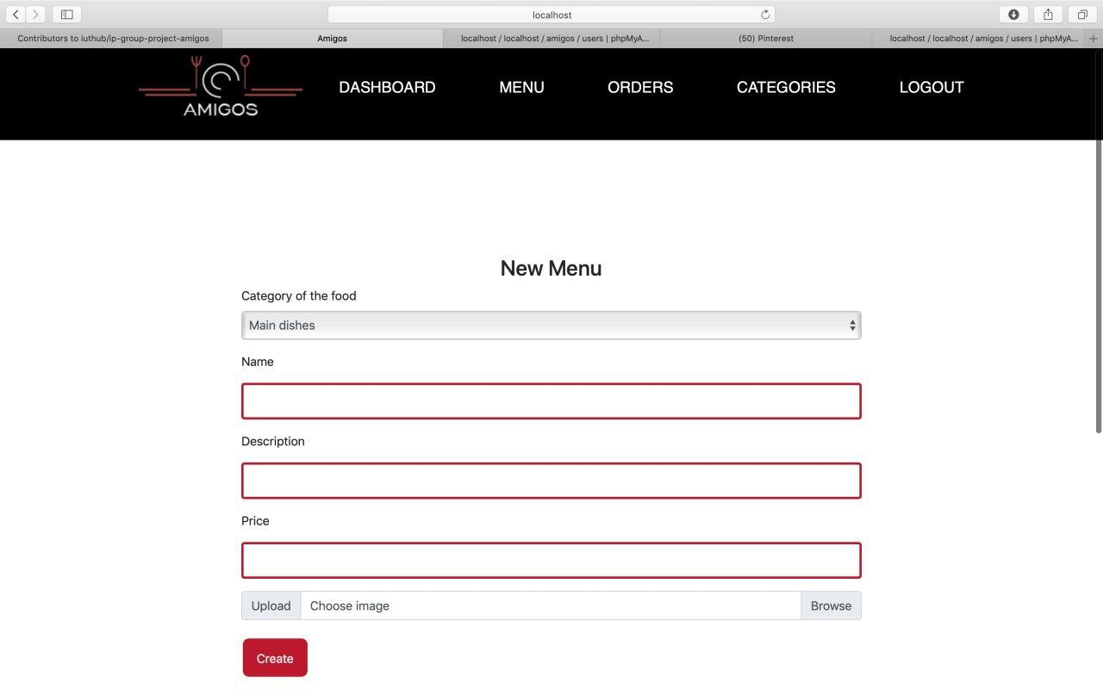

Creating menu page, every field except image is required, if image is not provided it gets default form public/img folder. Categories taken from categories db.

***User menu***

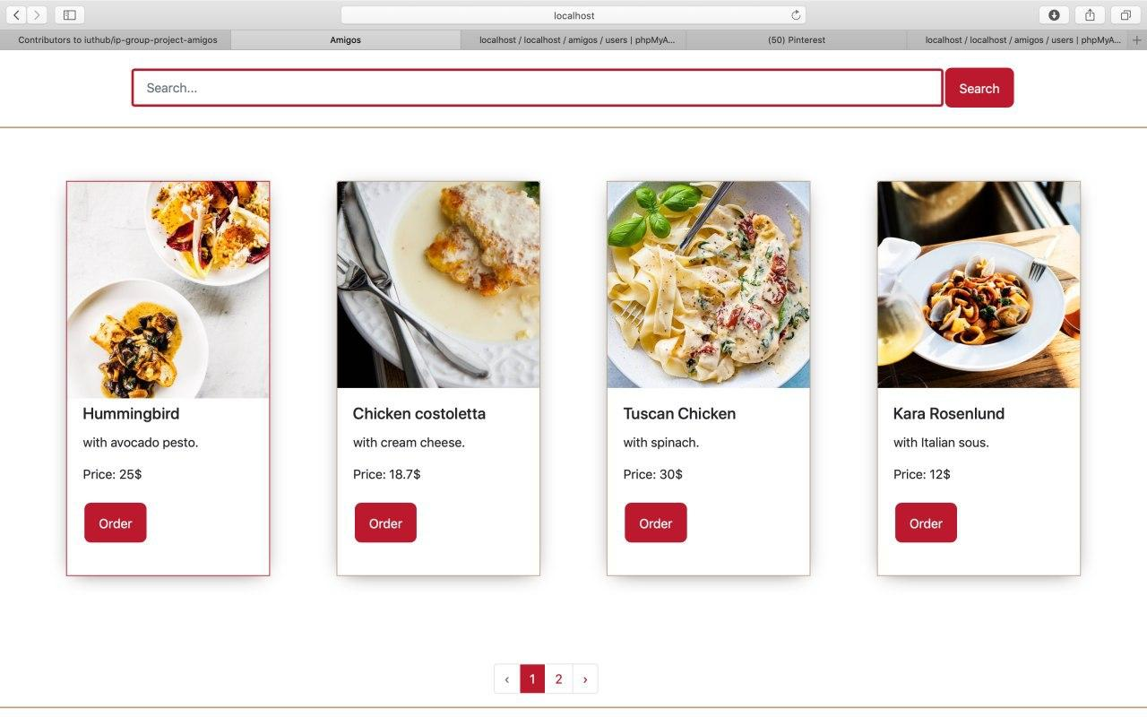

Menu page for users, it differs from admin menu page, here user can order specific food.

***User order confirm***

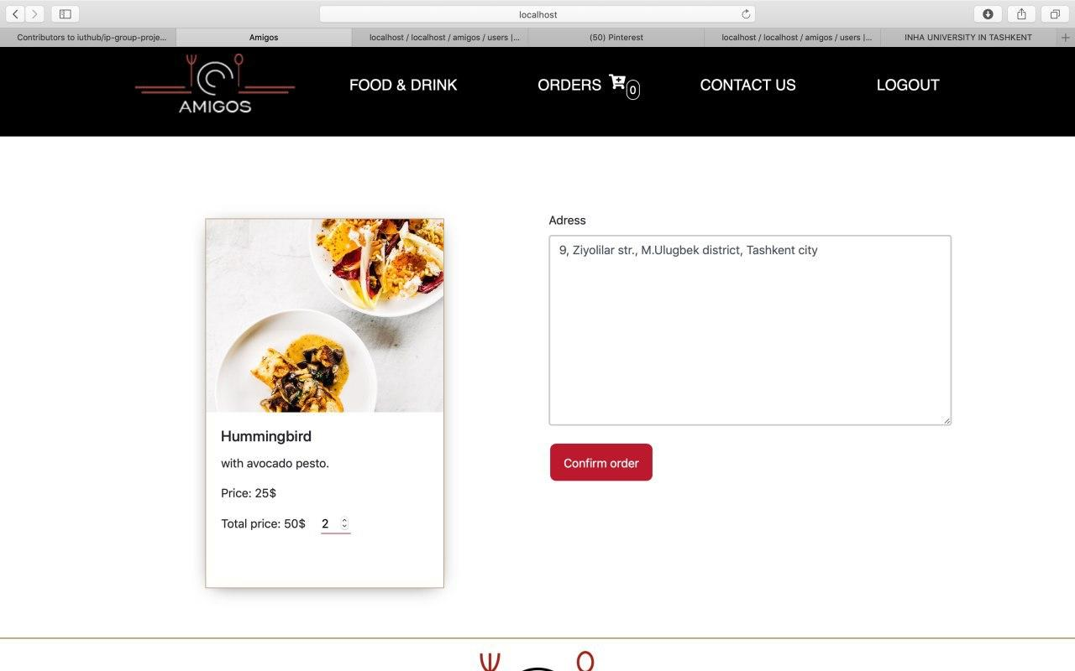

After clicking order in menu page, user can choose quantity of food, and provide address. User can see dynamically the cost of the food.

***User order control***

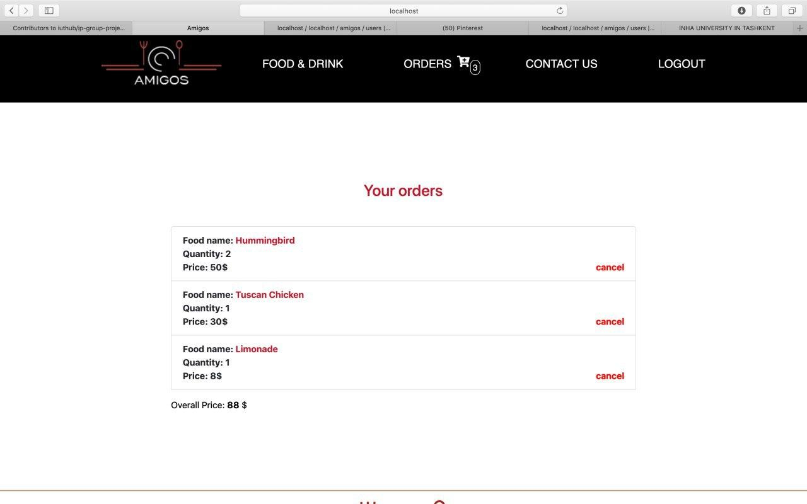

User can see his/her order, and cancel if order is not delivered yet.

***Admin order control***

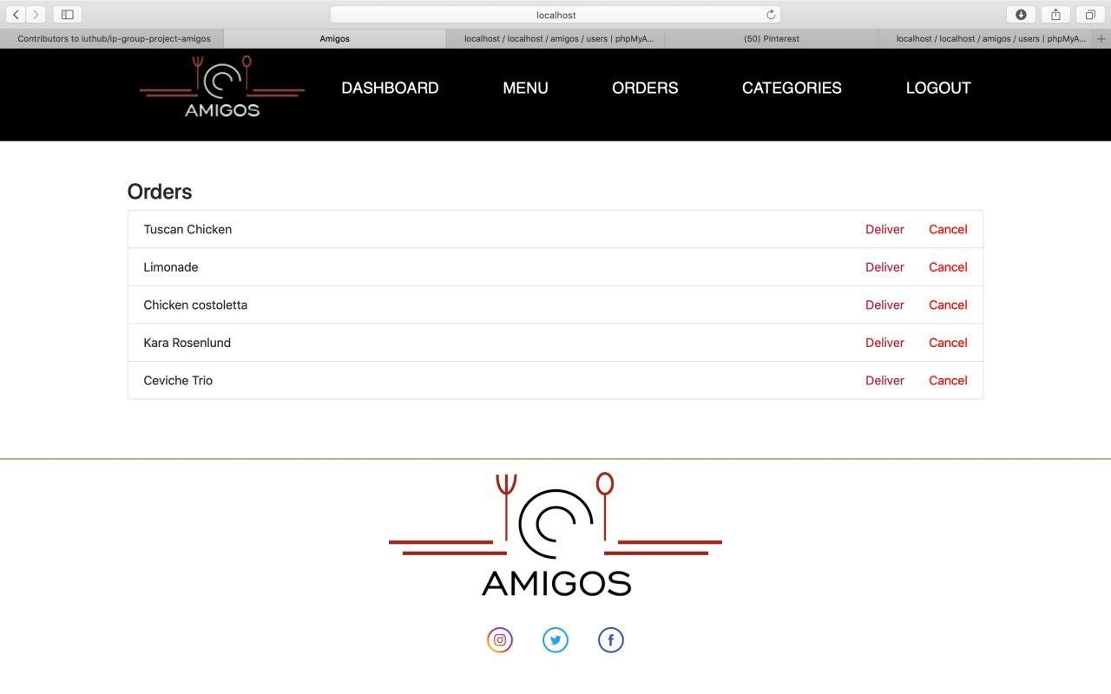

Admin can see all the orders, if order is delivered admin can click button deliver, so order deliver will be confirmed. Also, admin can cancel order too.

Summary of each member’s contribution to the project.

Sobirov Islom:

Has developed category, menu and order features of the website. Mainly worked with controllers with help of teammates.

Azimkulova Diyora:

Has developed order, category and some menu part of the project. Has worked in the pages, its html/css and some bootstrap stuff.

Mirzakhanov Akhrorboy:

Has developed models and database of order, category, and menu. Mostly written report. Designed and implemented some key pages.

Ismailova Sevilya:

Has made a landing page, developed a search function, login/register and partly menu page.

Jasurbekova Kamolakhon:

Has made a Contact Us page, worked mainly with styling of the pages, and contributed to the development of Dashboard.

Berdieva Janonakhon

Mainly worked with the design of our site. Made our logo and contributed to navbar and footer’s look.

Our Admin Profile in the website

email: amigosteamuz@gmail.com

Password: amigosteamforip

Simple user:

Email: [user@gmail.com](mailto:user@gmail.com)

Password: user0924U